1. Find the eno, ename of the employee whose salary is greater than 4000
2. Find the eno, ename salary of the employee whose salary is greater than 5000 and job status is professor.



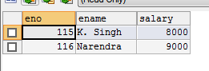

1. Find the eno ename salary of the employee whose dept no 20 or job status research fellow

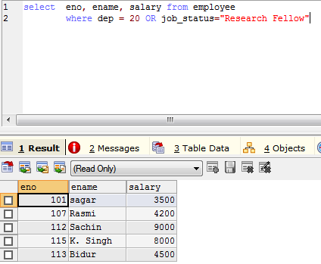



1. Find the eno ename age and salary from the employees where the age is between 24 and 28

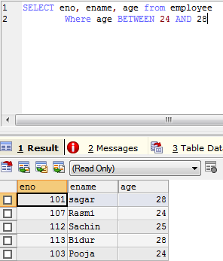



1. Find eno ename whose starting letter is SA

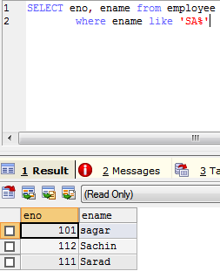



1. List all employee names with their project name

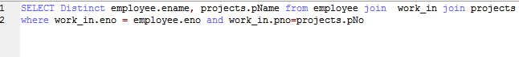

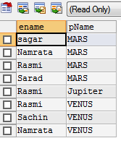

1. List name of all employees and their salary who are working in project mars or venus
2. List name of all employees and their salary who are working in project earth AND venus
3. List name and address of all employees who works in department which is located in pokhara